Midterm Project
Cybersecurity Plan for an AI-Integrated IIoT Healthcare System
Course: ITAI 3377 — Cybersecurity for AI & IIoT Systems
Submitted By: Judith Barrios
Group: Group 5
Date: Week 4
MT_JudithBarrios_Group5_ITAI_3377

1. System Design and Vulnerability Identification
1.1 System Selection
For this project I chose a hospital patient monitoring network as my hypothetical system. The idea is a modern hospital where patient devices like monitors, pumps, and wearables are all connected and feeding data into an AI system that helps doctors make faster decisions. I called it the Hospital Patient Monitoring Network, or HPMN. I picked healthcare because it is one of the most targeted industries for cyberattacks, and it made the vulnerabilities feel more serious and meaningful to think through.
1.2 System Components
The system is made up of the following parts:
- Medical IoT Devices — ECG monitors, smart infusion pumps, wearable vital-sign patches, glucose monitors, and portable imaging equipment
- Edge Gateways — small computers in each hospital ward that collect device data and forward it to the main servers
- Hospital Network — the Wi-Fi and wired connections linking everything together, along with the firewall and switches
- EHR Platform — the Electronic Health Records system where all patient data is stored
- AI Models — four tools covering sepsis prediction, X-ray analysis, medication dosing, and patient deterioration detection
- Clinical Staff Devices — laptops, tablets, and phones used by doctors and nurses to view alerts and patient records
1.3 How Data Flows Through the System
Patient devices collect biometric data continuously and send it over Wi-Fi to the edge gateway in each ward, which then forwards it to the AI server and EHR platform over an encrypted connection. The AI analyzes the incoming data and pushes alerts to clinical staff when something looks abnormal, while everything gets stored in the hospital's on-site data center. It sounds straightforward, but there are quite a few places in that chain where security can break down, which is what the next section covers.
1.4 Vulnerability Assessment
I went through the system layer by layer and identified where an attacker could get in or cause damage, ending up with 15 vulnerabilities across seven different areas. The table below summarizes all of them along with severity ratings and how each one could realistically be exploited.

# | Layer | Vulnerability | Severity | How It Could Be Exploited
1 | Device | Default passwords still enabled on devices | Critical | Attacker logs in remotely using factory-default credentials
2 | Device | Firmware not updated — known CVEs present | Critical | Remote code execution through unpatched vulnerabilities
3 | Device | No secure boot process | High | Malicious firmware loads silently at device startup
4 | Network | Patient data sent without encryption (MQTT) | Critical | Attacker on same Wi-Fi captures patient vitals in plaintext
5 | Network | No network segmentation between device types | High | Compromise one device then move laterally to EHR servers
6 | Network | Rogue Wi-Fi access points possible | High | Fake AP placed in a hallway intercepts device traffic
7 | Data | Patient records not encrypted when stored | Critical | Direct disk access exposes all PHI — major HIPAA violation
8 | Data | API endpoints not properly secured | Critical | Attacker pulls patient data through unsecured API calls
9 | Application | SQL injection in EHR web portal | Critical | Automated tool extracts the entire patient database
10 | Application | Session tokens in mobile app are too weak | High | Replay attack allows takeover of a clinician account
11 | AI Model | Adversarial inputs can fool diagnostic AI | High | Slightly altered X-ray image causes a wrong AI diagnosis
12 | AI Model | Training data pipeline can be poisoned | Critical | Injected bad data corrupts AI predictions over time
13 | AI Model | Model can be copied through repeated queries | Medium | Attacker reverse-engineers the AI model through the API
14 | Human | Staff vulnerable to phishing emails | High | Fake IT email tricks a nurse into giving up their credentials
15 | Physical | Devices left unattended in patient areas | Medium | Someone connects a USB drive and reflashes device firmware

1.5 System Diagram
The diagram below shows how all the components connect and where the main vulnerabilities sit. Data flows from patient devices up through the network and application layers to the AI models and security systems. The vulnerability numbers in the diagram match the IDs in the table above.
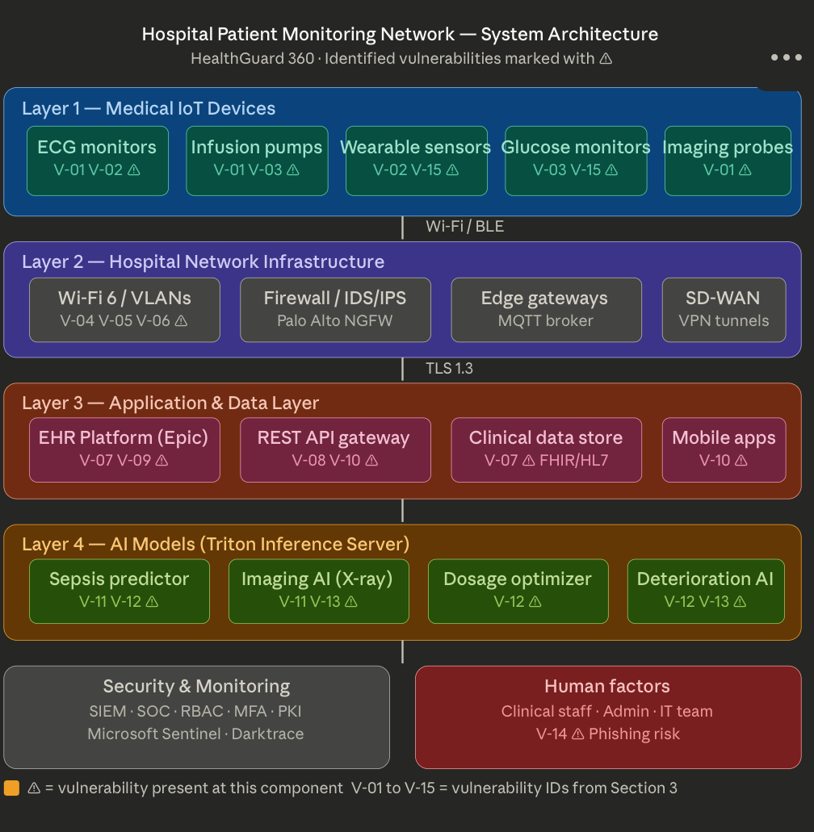

2. Defense Strategy Development
After mapping out all the vulnerabilities, I built a defense strategy around nine categories. The main idea was to never depend on a single control — if one layer fails, something else should catch it, which is the basic principle behind defense-in-depth.
2.1 Defense Measures
Secure by Design
A lot of IoT security problems come from insecure defaults that nobody ever changes, so the fix is making security the starting point rather than something bolted on afterward.
- Remove all default credentials during setup and force unique passwords at first boot
- Enable secure boot so only verified, signed firmware can run on devices
- Disable any ports or services that are not actively being used
- Use hardware security modules (HSMs) to store encryption keys safely on-device
Authentication and Access Control
Weak or stolen credentials are one of the most common entry points, so strengthening authentication across the board is a priority.
- Require multi-factor authentication (MFA) for all logins — no exceptions for admin accounts
- Implement Role-Based Access Control (RBAC) so staff only access what their role actually needs
- Use X.509 certificates to authenticate IoT devices rather than just passwords
- Require OAuth 2.0 for all API access so nothing interacts with the system without authorization
Encryption and Data Protection
Encrypting data both in transit and at rest means it is not very useful to an attacker even if they manage to get their hands on it.
- Enforce TLS 1.3 on all network connections — no plaintext traffic allowed anywhere
- Encrypt all stored patient data using AES-256
- Use encrypted MQTT with mutual TLS so device communications cannot be intercepted
Network Security
Segmenting the network limits how far an attacker can move if they do get in, and monitoring it closely means problems get caught faster before they can spread.
- Split the network into separate VLANs — one per device or user type
- Deploy a next-generation firewall with IDS/IPS to detect and block attacks in real time
- Use 802.1X Network Access Control so only authorized devices can connect
- Set up automated detection for rogue Wi-Fi access points
Secure Software Development
Building security into the development process from the start is much cheaper than patching things after the fact, and it catches the most common vulnerabilities before they ever go live.
- Use parameterized queries everywhere to prevent SQL injection
- Run automated SAST and DAST scans as part of every build pipeline
- Validate and sanitize all input on web forms and API endpoints
- Regularly scan third-party libraries for known vulnerabilities
Physical Security
Physical access is still a real attack vector, especially in a hospital where devices are spread across many floors and often left unattended in patient rooms.
- Attach tamper-evident seals to all IoT medical devices
- Require badge plus PIN to enter server rooms
- Block USB ports on medical devices using MDM software
Security Monitoring and Incident Response
Even strong defenses can be breached, so being able to detect and respond quickly is just as important as preventing the attack in the first place.
- Deploy a SIEM (Microsoft Sentinel) to collect and analyze logs across the whole system
- Use network detection and response (Darktrace) to flag unusual device behavior automatically
- Write incident response playbooks for the most likely attack scenarios ahead of time
- Maintain a 24/7 SOC with clear escalation paths for critical alerts
AI Model Security
AI models have a unique attack surface that many organizations still overlook, and in a healthcare setting the consequences of a compromised model are especially serious.
- Test models against adversarial examples before deployment using IBM's Adversarial Robustness Toolbox
- Apply differential privacy during training so the model does not memorize patient records
- Flag low-confidence AI predictions for human review instead of acting on them automatically
- Keep versioned, hashed copies of all deployed models so tampering can be detected
Human Factors
Technical controls only go so far, and people are still the biggest variable in any security plan, so building a security-aware culture has to be an ongoing effort.
- Mandatory security awareness training for all staff at least twice a year
- Regular phishing simulations so staff practice recognizing attacks in a realistic setting
- Enforce least privilege — no one gets more access than their role requires
- Create a simple way for staff to report suspicious activity without fear of blame

2.2 Implementation Plan

Phase | Timeline | Main Activities | Who's Responsible
1 — Foundations | Week 1 | Physical security, secure boot, encrypt stored data, block USB ports | Security Architect, Facilities
2 — Network & Access | Week 2 | VLAN setup, firewall config, MFA rollout, RBAC in Active Directory | Network Engineer, IAM Team
3 — Apps & Monitoring | Week 3 | Fix SQL injection, deploy SIEM and NDR, write IR playbooks | DevSecOps, SOC Team
4 — AI Security | Week 4 | Adversarial testing, API hardening, model integrity checks, WAF deployment | MLSecOps, Dev Team
5 — Testing | Week 5 | Full penetration test, vulnerability scans, tabletop IR exercise | Pen Test Team, All
6 — Ongoing | Week 6+ | Staff training, quarterly pen tests, compliance reviews | CISO, HR, Compliance

3. Penetration Testing Simulation
This was the most hands-on part of the project, where I simulated seven attack scenarios based on the vulnerabilities identified in Section 1 and switched between the attacker and defender role for each one. After every round I assessed what worked, what did not, and adjusted the defense strategy before moving on.
3.1 Test Scenarios and Results

# | Attack Scenario | What the Attacker Did | Did the Defense Hold? | What I Changed After
1 | Default credential attack | Used Hydra to try 500 common default passwords on the device management portal | Yes — lockout triggered after 5 attempts; MFA blocked access even with valid credentials | Reduced lockout to 3 attempts and added CAPTCHA after 2 failed logins
2 | MQTT traffic interception | Ran Wireshark on hospital Wi-Fi and subscribed to MQTT topics to read device traffic | Before the TLS fix: patient vitals were fully visible in plaintext. After: completely encrypted | Confirmed TLS 1.3 on all brokers and added client certificate pinning
3 | SQL injection on EHR portal | Ran SQLMap against the patient search field attempting UNION-based data extraction | Yes — WAF blocked automated scan signatures; parameterized queries stopped the injection | Added monthly DAST scans to the pipeline to catch future regressions
4 | Adversarial image attack on AI | Used Foolbox to add invisible changes to X-ray images submitted to the diagnostic AI | Partial — model misclassified 3 out of 10 adversarial images, not acceptable for clinical use | Retrained model with adversarial examples and added a low-confidence human review trigger
5 | Lateral movement from compromised device | Compromised a badge printer and tried to reach the EHR subnet via ARP spoofing | Yes — VLAN segmentation blocked the pivot; NDR flagged the ARP anomaly within 90 seconds | Configured automatic VLAN quarantine when NDR triggers an alert
6 | Phishing email to clinical staff | Sent a fake IT helpdesk email asking staff to reset their password through a malicious link | Partial — 2 out of 10 staff clicked the link; MFA prevented actual account compromise | Moved to monthly phishing simulations and added mandatory retraining for clickers
7 | Physical firmware reflash attempt | Located an unattended glucose monitor and tried to flash unsigned firmware via USB | Yes — secure boot rejected the firmware; MDM policy had already blocked the USB port | Added physical security patrols in wards and flagged unattended devices procedurally

3.2 Overall Assessment
Five out of seven attacks were fully stopped by the defenses I put in place, while the two partial gaps — the adversarial AI test and the phishing simulation — did not result in a full system compromise because other controls like MFA picked up the slack. The phishing result was still the most concerning, since a 20% click rate shows that even a well-designed technical defense has real limits when human behavior is part of the equation.

4. Final Report and Reflection
4.1 Summary
This project covered the full process of building a cybersecurity plan for a healthcare IIoT system, starting from system design all the way through live penetration testing. I identified 15 vulnerabilities across 7 attack surfaces, developed a layered defense strategy across 9 security domains, and validated those defenses through 7 simulated attacks. The strategy held up well overall, with the main gaps in AI model robustness and staff phishing awareness, both of which were addressed with targeted improvements after testing.
4.2 Individual Reflection
When I started this project, I honestly thought cybersecurity was mostly about keeping passwords strong and having a firewall in place, but going through the full design and testing process made me realize it is far more layered and interconnected than that. Working through a healthcare system specifically changed how I framed everything, because a compromised infusion pump or diagnostic AI is not just a data problem — it is a patient safety issue with consequences that are hard to reverse, and that context made every decision feel more serious.
The penetration testing portion was where I felt I learned the most, because sitting in the attacker role and actively trying to break something I had built was a completely different experience from reading about how attacks work in theory. The SQL injection test stood out in particular — SQLMap found the vulnerable field almost immediately and started pulling data within seconds, which made it very clear why secure coding practices need to be part of the development process from the very beginning rather than treated as something to go back and fix later.
The phishing simulation produced the result that surprised me the most, because even with MFA in place and security training on the books, two out of ten staff still clicked the fake email link. It made me realize that documenting a training program is not the same as actually preparing people to recognize a realistic attack in a busy, high-pressure environment like a hospital ward, where a well-crafted phishing email can look completely legitimate and staff have a dozen other things on their mind.
AI model security was the area that felt most new and unexpected to me, since I had not really considered before this project that you could feed a diagnostic model a barely-altered image and get a completely wrong clinical output with no visible difference to a human reviewer. Learning that adversarial attacks are a real, documented, and actively researched threat in medical AI made the whole section feel much more urgent than I expected going into it.
If I could go back and change one thing, I would have actually run a full walkthrough of the incident response playbooks rather than just writing them, because there is a meaningful difference between having a documented plan and knowing whether your response actually holds up when someone is simulating a live breach from detection all the way through to containment and recovery.
4.3 References
- NIST SP 800-82 Rev. 3 — Guide to Operational Technology (OT) Security. National Institute of Standards and Technology, 2023.
- OWASP Internet of Things Attack Surface Areas Project. OWASP Foundation, 2018. https://owasp.org/www-project-internet-of-things/
- HIPAA Security Rule — 45 CFR Part 164. U.S. Department of Health and Human Services.
- MITRE ATT&CK for ICS Framework v14. MITRE Corporation, 2023. https://attack.mitre.org/matrices/ics/
- IBM Adversarial Robustness Toolbox (ART) v1.13. IBM Research, 2022. https://github.com/Trusted-AI/adversarial-robustness-toolbox
- NIST SP 800-61 Rev. 2 — Computer Security Incident Handling Guide. NIST, 2012.
- Goodfellow, I., Shlens, J., & Szegedy, C. (2015). Explaining and Harnessing Adversarial Examples. ICLR 2015.
- Abadi, M. et al. (2016). Deep Learning with Differential Privacy. ACM CCS 2016.

